The Collective Impact Framework

Collective Impact is a framework to tackle deeply entrenched and complex social problems. It is an innovative and structured approach to making collaboration work across government, business, philanthropy, non-profit organizations and citizens to achieve significant and lasting social change. Collective Impact includes 5 key elements:

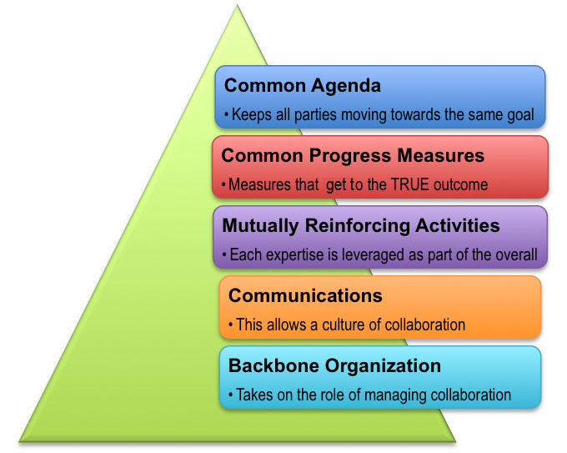

- All participants have a common agenda for change including a shared understanding of the problem and a joint approach to solving it through agreed upon actions.

- Collecting data and measuring results consistently across all the participants ensures shared measurement for alignment and accountability.

- A plan of action that outlines and coordinates mutually reinforcing activities for each participant.

- Open and continuous communication is needed across the many players to build trust, assure mutual objectives, and create common motivation.

- A backbone organisation(s) with staff and specific set of skills to serve the entire initiative and coordinate participating organisations and agencies.

The Collective Impact approach is premised on the belief that no single policy, government department, organisation or program can tackle or solve the increasingly complex social problems we face as a society. The approach calls for multiple organisations or entities from different sectors to abandon their own agenda in favour of a common agenda, shared measurement and alignment of effort. Unlike collaboration or partnership, Collective Impact initiatives have centralised infrastructure – known as a backbone organisation – with dedicated staff whose role is to help participating organisations shift from acting alone to acting in concert. John Kania & Mark Kramer first wrote about collective impact in the Stanford Social Innovation Review in 2011. For more information see: http://www.collaborationforimpact.com/collective-impact/.

